Creating an Amazon EBS Volume in AWS EC2
Step-by-step summary with console screenshots
Item | Detail
Service | Amazon EC2 → Elastic Block Store (EBS)
Region | Asia Pacific (Mumbai) – ap-south-1
Date performed | 20 September 2026
Objective | Create a new 66 GiB gp3 EBS volume that can later be attached to an EC2 instance
Result | Volume vol-0592c3a13f1ac017a created successfully, state: Available

1. Overview
Amazon Elastic Block Store (EBS) provides block-level storage volumes that behave like a physical hard drive attached to an EC2 instance. Data on an EBS volume persists independently of the instance, so it survives stop/start cycles and can be detached and re-attached elsewhere.
In this exercise, a new General Purpose SSD (gp3) volume was created from the EC2 console. The steps below follow the exact order of the screenshots taken during the process.

2. Steps Performed

Step 1: Open the Volumes page
From the EC2 console, open Elastic Block Store → Volumes in the left navigation menu. The region selector (top right) was set to Asia Pacific (Mumbai). The list is empty ("You currently have no volumes in this region") and the snapshot summary shows 0 / 0, which confirms this is a fresh start. Clicking the orange Create volume button opens the creation form.
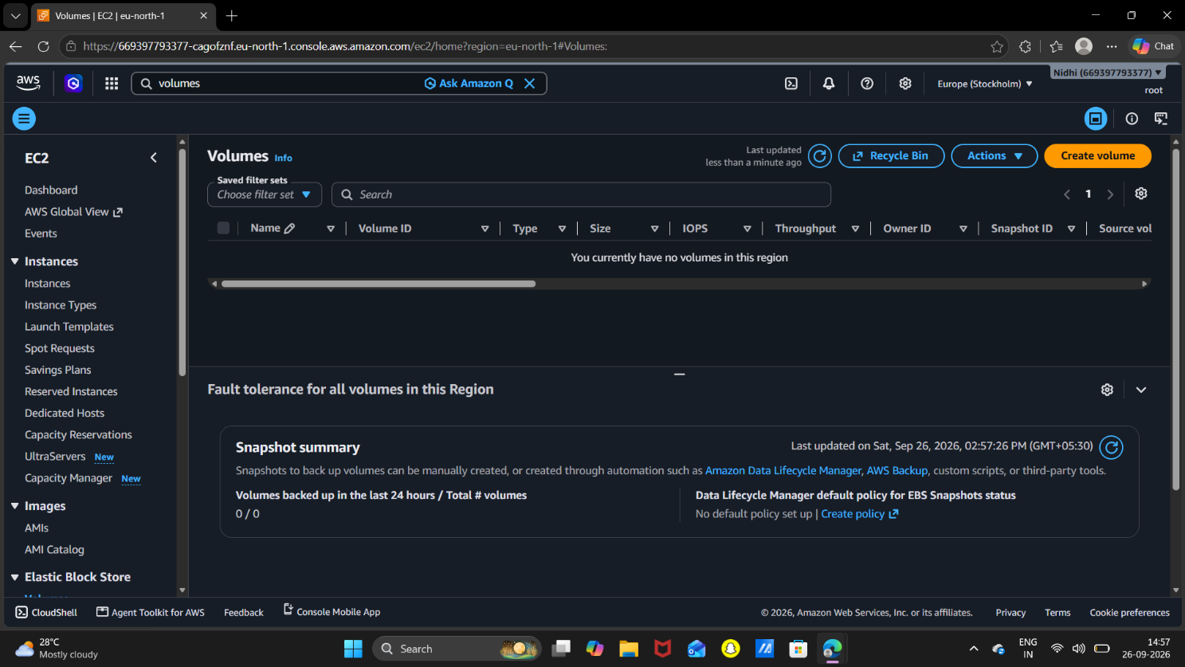

Screenshot 1: EC2 → Elastic Block Store → Volumes (no existing volumes)

Step 2: Configure the volume settings
On the Create volume page, the following settings were used:
Setting | Value chosen | What it means
Volume type | General Purpose SSD (gp3) | Latest-generation general-purpose SSD; performance is set independently of size.
Size | 66 GiB | Allowed range is 1 GiB to 65,536 GiB.
IOPS | 3000 | Baseline for gp3 (range 3,000–80,000). Included at no extra cost.
Throughput | 125 MiB/s | Baseline for gp3 (range 125–2,000 MiB/s).
Availability Zone | ap-south-1a (aps1-az1) | Must match the AZ of the EC2 instance the volume will be attached to.
Snapshot ID | Not used | The volume is created empty instead of being restored from a snapshot.
Encryption | Not enabled | "Encrypt this volume" was left unchecked, so data is stored unencrypted.

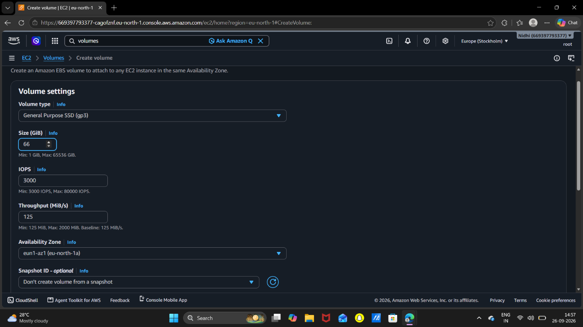

Screenshot 2: Create volume form with volume type, size, IOPS, throughput and Availability Zone
Important: A volume can only be attached to an instance in the same Availability Zone. Always check the instance's AZ before choosing one here.

Step 3: Review tags and create the volume
Scrolling down shows the optional Tags section and the Snapshot summary. No tags were added (up to 50 are allowed). The snapshot summary only tells whether a Data Lifecycle Manager policy will back up the volume based on its type and tags. After reviewing the form, clicking Create volume submits the request.
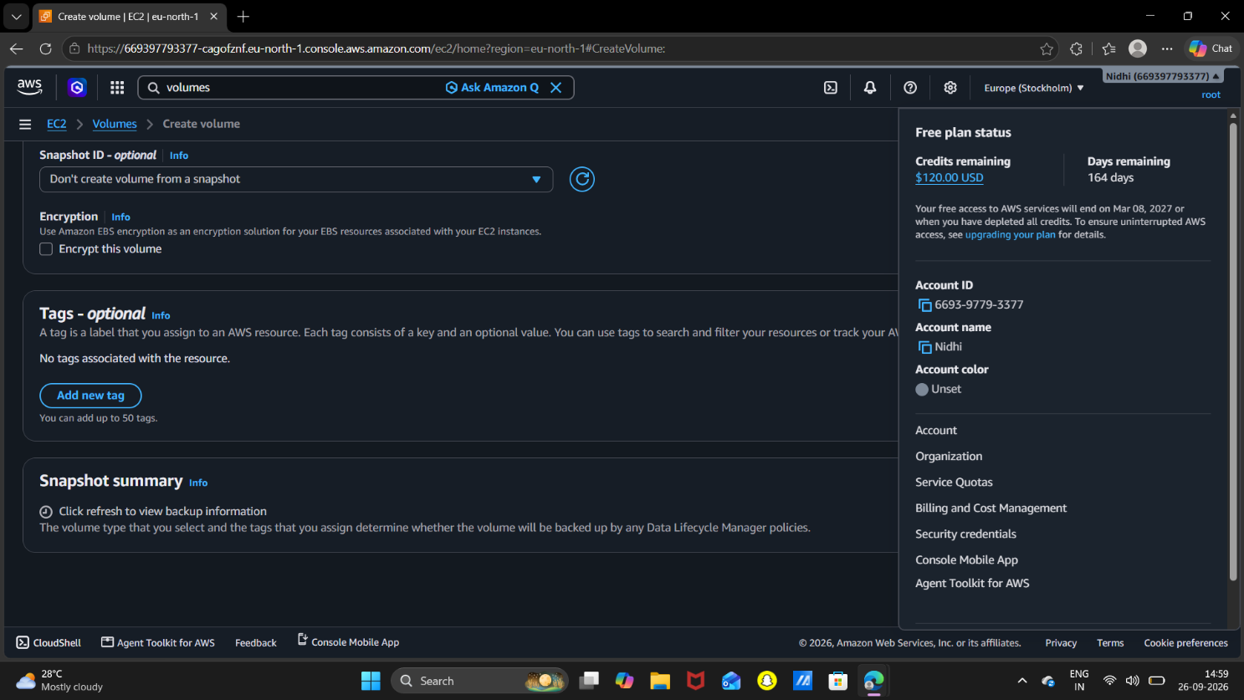

Screenshot 3: Tags (optional), Snapshot summary and the Create volume button

Step 4: Verify the volume details
After creation, AWS opens the details page of the new volume, vol-0592c3a13f1ac017a. Key values confirmed on this page:
- Volume state: Available (ready to be attached).
- Size / Type: 66 GiB, gp3, with 3000 IOPS and 125 MiB/s throughput.
- Availability Zone: aps1-az1 (ap-south-1a).
- Attached resources: none (the volume is not yet connected to any instance).
- Encryption: Not encrypted. Multi-Attach: No. Created: 20 Sep 2026, 22:07:28 IST.
- 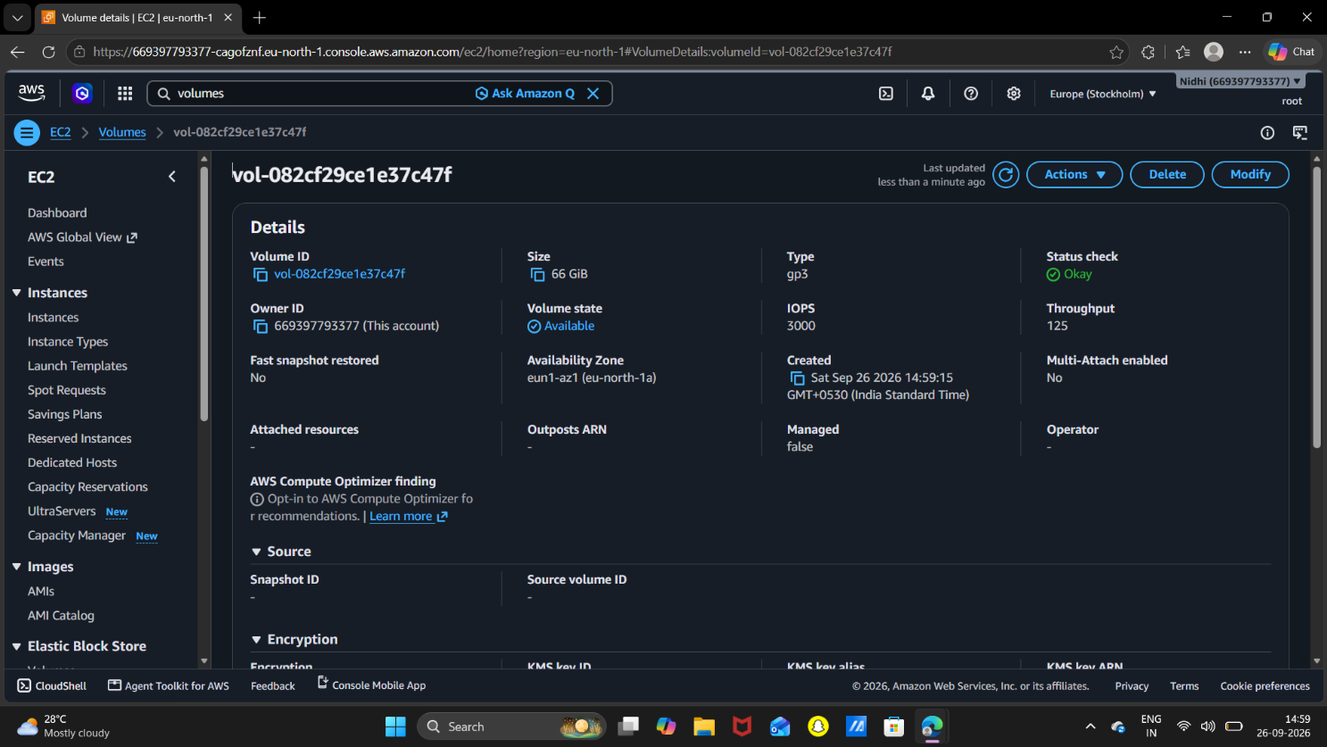
Screenshot 4: Volume details page showing state "Available"

Step 5: Check the status checks
The Status checks tab at the bottom of the details page confirms the health of the volume. Status check is Okay and I/O status is Enabled. Auto-enabled I/O shows Disabled, and I/O performance shows Not applicable because that feature only applies to volumes that are attached (io1, io2 and gp3). This is expected for a newly created, unattached volume.
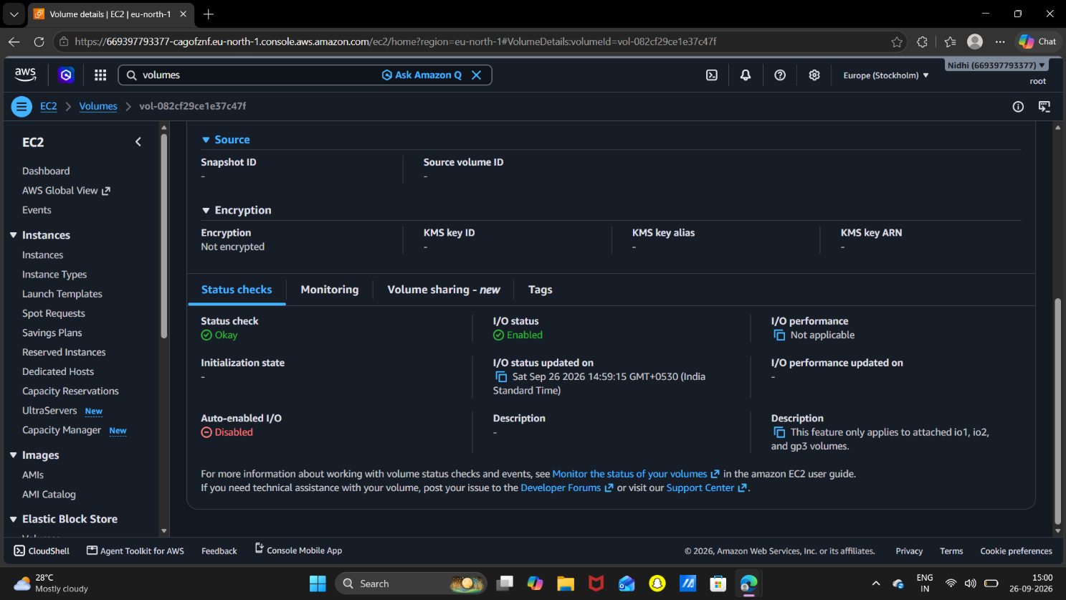

Screenshot 5: Status checks tab (Status check: Okay, I/O status: Enabled)

3. Final Configuration Summary
Parameter | Value
Volume ID | vol-0592c3a13f1ac017a
Type | gp3 (General Purpose SSD)
Size | 66 GiB
IOPS / Throughput | 3000 IOPS / 125 MiB/s
Availability Zone | ap-south-1a
Encryption | Not encrypted
Multi-Attach | Disabled
Volume state | Available
Status check | Okay
Attached to | Nothing yet

4. Next Steps: Attach and Use the Volume
The screenshots cover volume creation only. To actually use the storage, the volume must be attached to an instance and then formatted and mounted. These steps were not part of the screenshots above.

4.1 Attach the volume (console)
- Select the volume → Actions → Attach volume.
- Choose the target EC2 instance (it must be in ap-south-1a) and keep the suggested device name, for example /dev/sdf.
- Click Attach volume. The state changes from Available to In-use.

4.2 Format and mount (Linux instance)
Connect to the instance over SSH or EC2 Instance Connect, then run:
# 1. List block devices (new disk has no mount point)
lsblk

# 2. Check for a filesystem ("data" means empty)
sudo file -s /dev/nvme1n1

# 3. Create a filesystem (only on a NEW, empty volume!)
sudo mkfs -t xfs /dev/nvme1n1

# 4. Create a mount point and mount the volume
sudo mkdir /data
sudo mount /dev/nvme1n1 /data

# 5. Verify
df -h

Note: On newer Nitro-based instance types the device shows up as /dev/nvme1n1 even if it was attached as /dev/sdf. On older types it may appear as /dev/xvdf. Always confirm the name with lsblk first.
To make the mount survive a reboot, add an entry to /etc/fstab using the volume UUID (from sudo blkid) with the nofail option, then test with sudo mount -a.

5. Best Practices and Things to Keep in Mind
- Encryption: this volume is unencrypted. For anything sensitive, enable "Encrypt this volume" at creation time. Encryption of an existing volume is done by taking a snapshot and creating an encrypted copy.
- Tagging: add tags such as Name and Project so the volume is easy to find and its cost can be tracked.
- Backups: create snapshots regularly (or use Data Lifecycle Manager) because an EBS volume is not a backup by itself.
- Cost: EBS volumes are billed for provisioned size for as long as they exist, even when unattached. Check your account's free-tier limits, as 66 GiB may exceed them.
- gp3 tuning: IOPS and throughput can be raised later via Modify without changing the size; size can be increased but never decreased.
- Same AZ rule: to move data to another AZ, create a snapshot and restore a new volume from it in the target AZ.

6. Clean-up
If the volume is no longer needed, avoid unnecessary charges by removing it: first detach it (Actions → Detach volume, and unmount it inside the OS beforehand), then use Actions → Delete volume. Deletion is permanent unless a snapshot was taken earlier.

